**NOTE: This is an official document by Indexademics. Unless otherwise stated, this document may not be accredited to individuals or groups other than the club IDX, nor should this document be distributed, sold, or modified for personal use in any way.**

**IDX G9 CHEMISTRY H STUDY GUIDE ISSUE 4**

**By Ivan and Gavin**

**6.1 Wave Nature of Light**

* Light is a kind of electromagnetic radiation. Electromagnetic wave consists of electric and magnetic fields oscillating at right angles.
* Wavelength (λ): The distance between corresponding points on adjacent waves.
* 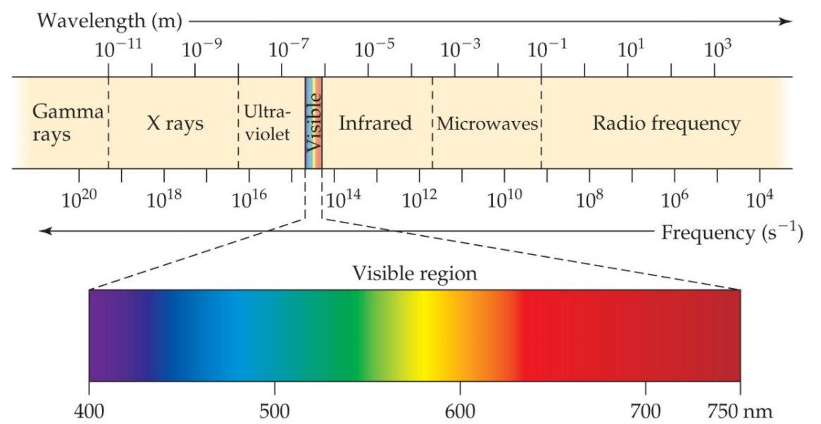Frequency (): The number of waves passing a given point per unit of time, unit Hertz (Hz)
* All electromagnetic radiation travels at the same velocity: The **speed of light (*c*) is** **3.00 x 10^8 m/s**.
* Equation:
* Different colors of light correspond to different wavelengths and frequencies, with violet having the shortest wavelength and highest frequency, while red has the longest wavelength and lowest frequency. Higher frequency electromagnetic radiation has higher energy.

**6.2 Quantized Energy and Photons**

* Plank explained by assuming energy comes in packets called quanta.
* The energy of a single quantum:
* Plank Constant (h) =
* **Photoelectric Effect**
* Electrons are ejected when light shines on a metal
* Photon: a particle of electromagnetic radiation with no mass that carries a quantum of energy.
* The minimum energy required to eject electron is .
* Only when > , electrons can be emitted.
* Kinetic energy of electron emitted:

**6.3 Line Spectra and the Bohr Model**

* Atomic emission spectrum
  + Continuous spectrum: one color fades gradually into the next color (e.g. visible spectrum)
  + Atomic emission spectrum of an element is the set of frequencies of the electromagnetic waves emitted by atoms of the element.
  + The atomic emission spectrum is unique to each element, consisting of specific frequencies of light emitted by atoms.
* Bohr Model
  + Assumed electrons move in circular orbits around the nucleus designated by a quantum number n (n=1,2,3...)
  + Energy is only absorbed or emitted to move an electron from one “allowed” energy state to another.
  + Electron on the other allowable energy levels are excited states.
  + Ground State: The lowest energy state (n=1).
  + Excited States: Higher energy levels (n=2, 3, ...).
  + Photon Emission: When an electron drops to a lower energy level, it emits a photon corresponding to the energy difference.

Bohr's model effectively explains hydrogen's spectrum but fails for multi-electron atoms and does not account for electron behavior in circular orbits.

* Hydrogen’s Line Spectrum
  + Electron can be excited to higher energy level when it absorbs energy. When the atom is in an excited state, the electron can drop from the higher energy level to a lower energy level.
  + 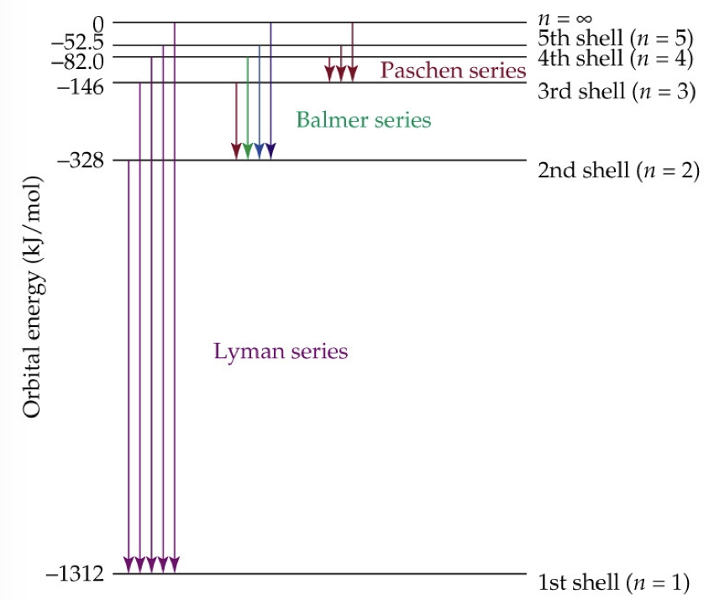Atom emits a photon corresponding to the difference between the energy levels associated with two orbits. Only certain frequencies of the radiation can be emitted.

**6.4 The Wave Behavior of Matter**

* 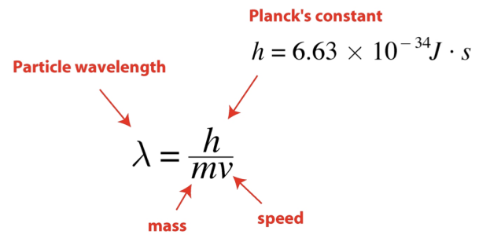Louis de Broglie theorized that if light can have material properties, matter should exhibit wave properties
* Heisenberg Uncertainty Principle
  + The position and the velocity/momentum of a moving electron cannot simultaneously be measured and known exactly.

**6.5 Quantum Mechanics and Atomic Orbitals**

* Schrödinger -- Quantum Mechanical Model
* Atomic Orbitals: represented pictorially as a region of space in which there is a high probability of finding an electron.
* s: Spherical shape
* p: Dumbbell shape
* d: Four-leaf clover shape
* f: Complex shapes

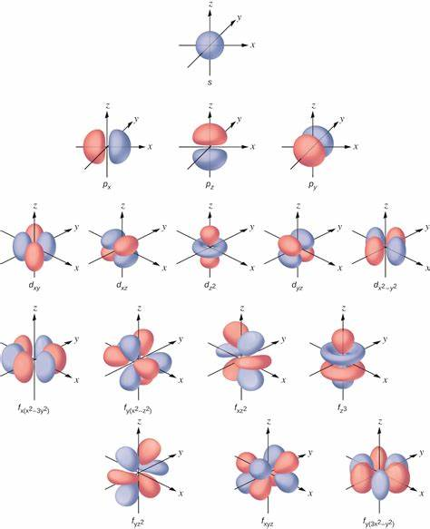

**6.6 Representations of Orbitals**

* Number of orbitals (due to different orientations): 1s, 3p, 5d, 7f
* Number of sublevels in an energy level: , for the principal quantum number

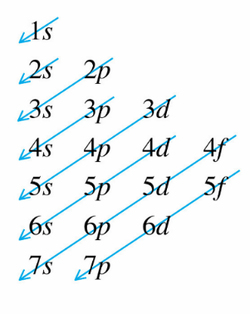Total number of orbitals in an energy level:

* Maximum number of electrons in an energy level:

**6.6 Representations of Orbitals**

* Degenerate orbitals: orbitals with the same energy
* Aufbau Principle: electrons in different orbitals are filled in the increasing order of energy
* The order of filling is:

1s < 2s < 2p < 3s < 3p < 4s < 3d < 4p < 5s < 4d < 5p < 6s < 4f < 5d < 6p < 7s < 5f < 6d < 7p

* Pauli Exclusion Principle: an atomic orbital may describe at most two electrons with the opposite spin
* 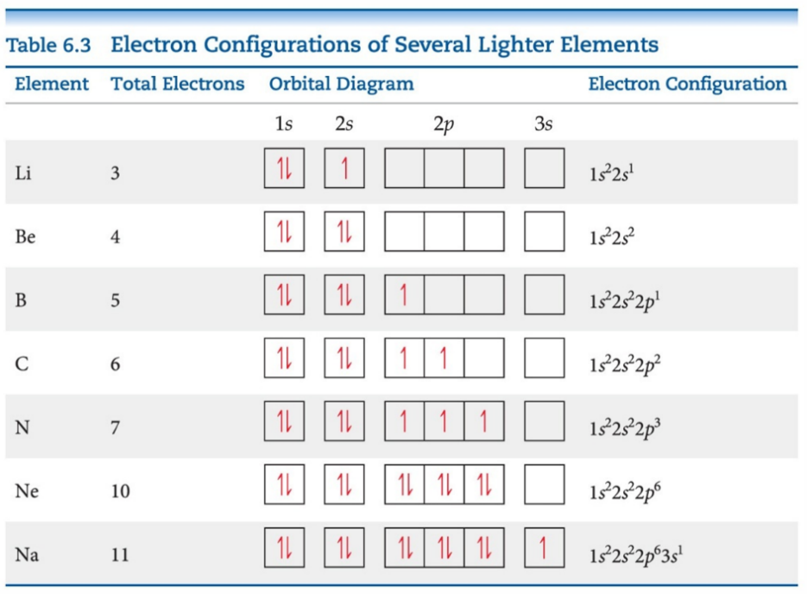Hund’s Rule: for degenerate orbital, the lowest energy is attained when the number of electrons with the same spin is maximized
* Orbital Diagrams: each box in the diagram represents one orbital, half-arrows represent the electrons, the direction of the arrow represents the relative spin of the electron.
* Electron Configurations: a number denoting the energy level, a letter denoting the type of orbital, a superscript denoting the number of electrons in those orbitals.
* 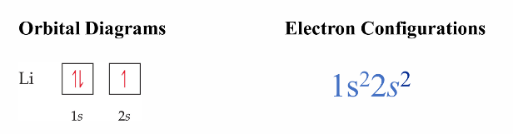Abbreviated Electron Configuration (condensed electron configurations, noble gas notation): the electron configuration of the nearest noble-gas element of lower atomic number (core electrons) is represented by its chemical symbol in brackets
* Core electrons: the inner-shell electrons
* Outer-shell electrons: the electrons given after the noble-gas core
* Valence electrons: the electrons involved in chemical bonding
* 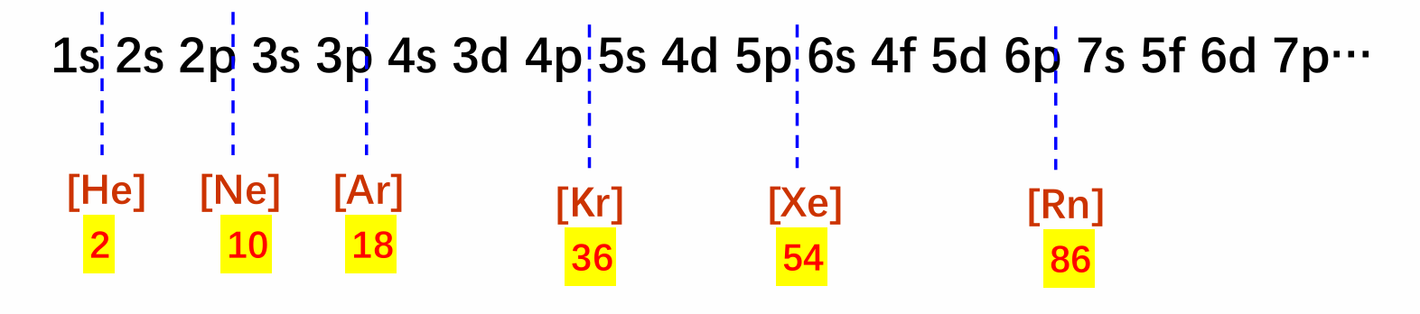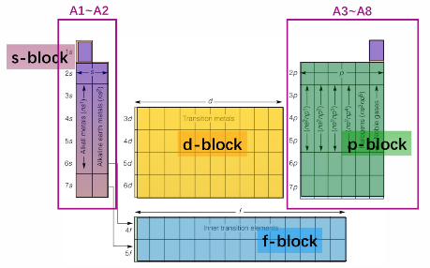Tips in writing down the electron configurations of elements using the periodic table:

1. Locate the element, as in which block and group it is in, and the nearest noble gas
2. Put together all the orbitals before the block
3. Count the group of the element to determine the number of electrons in the unfilled orbital

For 2nd and 3rd periods: [ ] ns np

For 4th and 5th periods: for A1 to A2 – [ ] ns, for A3 to A8 – [ ]

For 6th to 7th periods: for A1 to A2 – [ ] ns, for A3 to A8 – [ ]

* Exceptions:

Some elements have electron configurations that differ from expected due to stability preferences of half-filled and fully filled sublevels.

Cu:

Ag:

Au:

Cr:

Mo:

* Electron Configurations for ions:
  + Metal atoms: lose electrons, cations
  + Nonmetal atoms: gain electrons, anions
  + Transition metals: lose outmost shell electrons first, then lose inner d level electrons
* Electron configuration of excited state: the electron configuration for an excited state electron shows one or more electrons in a higher energy level

**Extension for Chapter 1**

* Rules for rounding numbers (only for lab and statistical results):
  + If the number right next to the last sig. fig. is less than 5, don’t change the last significant figure.
  + If the number right next to the last sig. fig. is greater than 5, round up the last significant figure.
  + If the number right next to the last sig. fig. is equal to 5 and is followed by a non-zero, round up the last significant figure.
  + “四舍六入，五成双”
* A measurement is a comparison between an unknown quantity and a standard
* Significant Digits: the valid/reliable digits in a measurement
  + Last digit in a measurement is an estimated/uncertain digit
  + Counting Significant Digits:
    1. All non-zero digits and any zeros contained between non-zero digits (6 s.f. in 300042)
    2. Exact numbers and constants have infinite significant digits ( s.f. in )
    3. Trailing zeros if there is a decimal point (3 s.f. in 200.)
    4. Trailing zeros do not count unless scientific notation is explicitly used (3 s.f. in 2990 while 4 s.f. in )
  + Addition and Subtraction: round the result to have as many decimal places as the measured number with the smallest number of decimal places.
  + Multiplication and Division: round the result to have as many s.f. as the measured number with the smallest number of s.f..
* Uncertainty: the variation in measured data
  + Systematic Error: consistent or reproducible error that affects the accuracy of a measurement. Caused by instrument, environment, or methodology
  + Random Error: an unpredictable variation in measurements. Caused by human or environment fluctuations
  + Accuracy: how close a measurement is to the accepted value
  + Precision: the repeatability of the measurement using a given instrument (number of s.f.)
  + Instrument Limit of Error (ILE): the maximum amount by which a measurement made by an instrument can deviate from the true value. Generally least count of 1/2 of least count
  + Deviation: the amount by which a single value differs from the average
  + Representing Experimental Result:
    1. Absolute uncertainty/error:
    2. Relative uncertainty:
    3. Relative Error: (measured value – expected value) / expected value
    4. Percentage uncertainty/error: relative uncertainty
* Error Propagation
  + Addition and Subtraction:
  + Multiplication and Division:
  + For multiplication by an exact number, multiply the uncertainty by the same exact number
  + Powers: for ,

**7.1 Development of Periodic Table**

In the late 1790s, Antoine Lavoisier compiled a list of 23 known elements. By 1870, approximately 70 elements were recognized.

* 1860: Chemists agreed on a method for determining atomic masses.
* 1864: John Newlands proposed the "octave" rule, where properties repeat every eighth element.
* 1869: Dmitri Mendeleev and Lothar Meyer connected atomic mass with elemental properties.
* Mendeleev is credited for publishing first and demonstrating the usefulness of his periodic table.
* Mendeleev observed periodic patterns in chemical and physical properties when elements were ordered by atomic mass.
* Elements in vertical columns exhibited similar properties.
* Mendeleev predicted the existence and properties of undiscovered elements, leaving blank spaces in his table.
* Predicted elements: scandium, gallium, germanium (eka-silicon).

**Mendeleev’s Contributions**

* Corrected atomic masses of several elements (e.g., Be, In, U, Os, Ir, Pt, Y, Ti).
* Sometimes broke the pattern of increasing atomic masses to group similar properties.
* Left spaces for unknown elements and successfully predicted scandium, gallium, and germanium.

**The Modern Periodic Table**

In 1913, Henry Moseley arranged elements by atomic number instead of atomic mass, revealing a clear periodic pattern.

**7.2 Effective Nuclear Charge**

In multi-electron atoms, electrons are attracted to the nucleus but also repelled by other electrons.

* The nuclear charge experienced by an electron depends on attraction and repulsion factors.
* Valence electrons experience less attraction due to core electron repulsion.
* Shielding effect: Inner electrons repel outer (valence) electrons, decreasing attraction from nuclear charge (Z).
* Effective nuclear charge (Zeff) is the charge felt by outermost electrons after accounting for shielding.
* Zeff for outermost electrons is smaller than for inner electrons due to screening effects.
* Inner electrons have a greater impact on screening than outermost electrons.
* Zeff decreases in the order: s, p, d, f for electrons on the same principal energy level.
* Zeff increases from left to right across a period.
* Going down a column, Zeff increases slightly due to less effective screening by diffuse core electron clouds.